**Platform Selection:**

There are three types of Blockchain platforms:

1. Public BC
2. Private BC
3. Consortium BC
4. **Public BC:** Public BCs are open source and not permissioned. Anyone can join the network and participate in the consensus mechanism without permission. Anyone can download the code and start running a public node on their local device., validating the transactions in the network, thus participating in the consensus mechanism. Anyone can send transactions through the network and expect them to be included in the BC if they are valid. Transactions are transparent but anonymous or pseudonymous.

Ex. Ethereum, Bitcoin

1. **Consortium BC:** Consortium BC operate under the leadership of a group. As opposed to public BC, they do not allow any person with internet access to participate in the process of verifying transactions. These BCs are faster, scalable and provide more transaction privacy. The consensus process is controlled by a pre-selected set of nodes. Ex. One might imagine a consortium of 15 financial institutions, each of which operates a node and of which 10 must sign every block for the block to be valid. The right to read the BC may be public or restricted to the participants.

Ex. Corda, Hyperledger Fabric

1. **Private Blockchain:** In a private BC, write permissions are kept centralized to one organization. Read permissions may be public or restricted to an arbitrary extent. Example applications include Database management, auditing etc. which are internal to a single company. Private BCs are a way of taking advantage of BC technology by setting up groups and participants who can verify transactions internally. This puts us at the risk of security breaches just like in a centralized system However, private Blockchains have their use case especially when it comes to scalability and security.

Ex. Monax

**BIGGEST ADVANTAGE OF CONSORTIUM BC: The identity of all the participants is known.**

**Why Consortium over Public?**

1. Public is permission less. The network participants are anonymous. They could be malicious.

Consortium is permissioned. The network participants are identified and trusted.

1. The consensus mechanism in a Public BC is POW or POS. It leads to large energy consumption, no finality and 51% attack.

The consensus mechanism in a consortium BC is Voting or multi party consensus algorithm. This is lighter, Faster, low energy consumption and enables finality.

1. The Block time in Public BC is long like 10 mins or more.

The Block time in Consortium BC is short 100x msec.

Consortium BC best suits our application as we need the application to run in a network of certain known nodes and do not want anyone unknown to join the network.

Some consortium platforms to be considered:

1. Ethereum Quorum
2. Hyperledger Fabric
3. BigchainDB
4. **Ethereum Quorum:**
   * Ethereum is a Public BC. But it can also be used to implement permissioned Blockchains.
   * **JP Morgan’s Quorum** is the most usable enterprise version of Ethereum.
   * **QUORUM:** Uses **RAFT and INSTANBUL BFT** as consensus mechanism. They are very efficient in Consortium BC with small number of nodes and transaction finality.
   * **Quorum** also provides authentication of nodes and private transaction between participants.
   * Quorum supports Solidity programming language for writing Smart Contracts.
   * Quorum is ideal for any application requiring high speed and high throughput processing of private transactions within a permissioned group of known participants.
   * Quorum is a fork of Ethereum. Hence it is very stable and mature.

**Comparison with Ethereum:**

* Privacy: Quorum supports private transactions and private contracts through public/private state separation and utilizing Constellation, a peer-to-peer encrypted message exchange for directed transfer of private data to network participants.
  + Alternative consensus mechanism: With no need of POW and POS in a permissioned network, Quorum instead offers multiple consensus mechanism that are more appropriate to consortium chairs.
  + Network and peer permissions management – Only validated and authorized people can be a part of the network. (pre-approved by a designated authority)
  + Enhanced transactions and contract privacy- Provides confidentiality of data. Has both Public (similar to Ethereum) and private transactions.
  + Voting based consensus mechanism- Called QuorumChain.
  + Better performance.

1. **Hyperledger Fabric:**
   * Hyperledger Fabric is the most mature blockchain platforms in Hyperledger collection.
   * Supports private transactions, private channels and zero knowledge proofs.
   * It follows a permissioned network and expects only the participants within the network to reach consensus.
   * Thus, enhances privacy and performance can be improved.
   * Supports languages like Node.js, Java and Go for SC programming. (called the chain code)

**Hyperledger Features:**

* + Permissioned network: Establish decentralized trust in a network of known participants rather than a public network with no identity.
  + Confidential Transactions: Expose only the data you want to share to the parties you want to share it with.
  + No cryptocurrency.
  + Members of a Hyperledger Fabric enroll through a Membership Service Provider (MSP)
  + Offers the ability to create channels, allowing a group of participants to create separate ledger of transactions.
  + Chaincode can be implemented in Go and Node.

Comparison between Ethereum quorum and Hyperledger Fabric

PS: Please ignore Corda

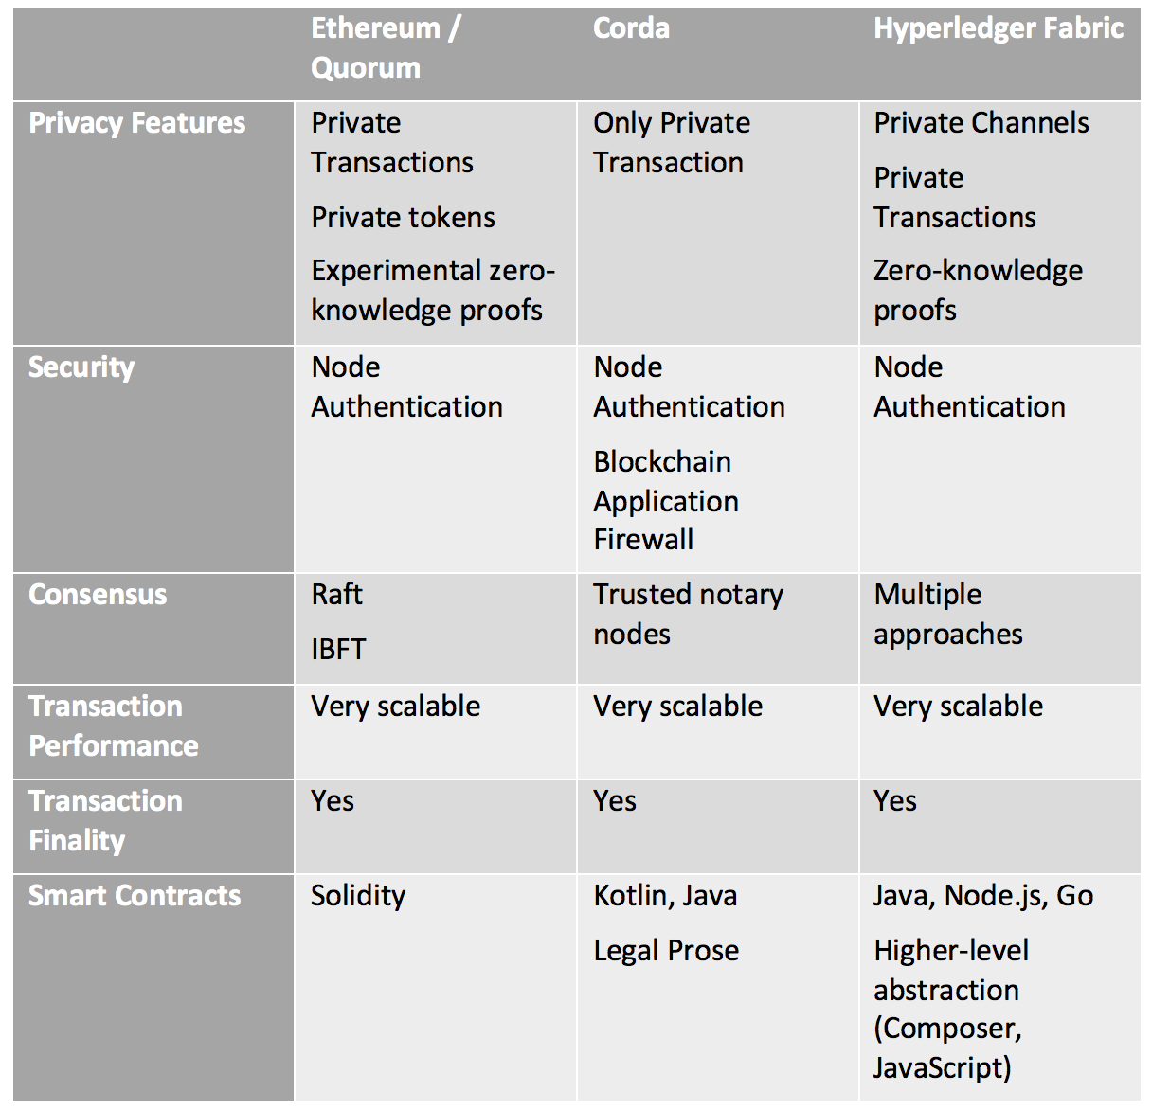

1. **BigchainDB:**

* **BigchainDB is a Blockchain Database**
* In a BigchainDB Blockchain, every participant of the BC network has a copy of a NO-SQL database. The consensus mechanism of the BC makes sure that all the copies are synchronised, and no alteration of the data is possible.
* “With high throughput, low latency, powerful query functionality, decentralized control, immutable data storage and built-in asset support, BigchainDB is like a database with Blockchain characteristics”
* BigchainDB allows developers and enterprise to deploy blockchain proof-of-concepts, platforms and applications with a blockchain database, supporting a wide range of industries and use cases.
* As stated in the BigchainDB documentation:

**How BigchainDB is Good for Asset Registrations & Transfers**

* + BigchainDB can store data of any kind (within reason), but it’s designed to be particularly good for storing asset registrations and transfers:
  + The fundamental thing that one sends to a BigchainDB network, to be checked and stored (if valid), is a transaction, and there are two kinds: CREATE transactions and TRANSFER transactions.
  + A CREATE transaction can be used to register any kind of asset (divisible or indivisible), along with arbitrary metadata.
  + An asset can have zero, one, or several owners.
  + The owners of an asset can specify (crypto-)conditions which must be satisfied by anyone wishing transfer the asset to new owners. For example, a condition might be that at least 3 of the 5 current owners must cryptographically sign a TRANSFER transaction.
  + BigchainDB verifies that the conditions have been satisfied as part of checking the validity of TRANSFER transactions. (Moreover, anyone can check that they were satisfied.)
  + BigchainDB prevents double-spending of an asset.
  + Validated transactions are [“immutable”](https://docs.bigchaindb.com/en/latest/immutable.html).
* **Advantages of BigChainDB:**
  + Provides a globally accessible database to store land titles and transactions
  + High capacity and throughput for millions of records
  + Data immutability that brings trust and auditability to the records
  + Query technology that enables quick retrieval transaction histories
  + Interoperability with [IPFS](https://ipfs.io), to store large files and media

Present Selection: BigchainDB

Here’s why?

1. Benben: a start-up doing land registration and transfers in Ghana uses BigchainDB as their platform. Please refer: <https://www.bigchaindb.com/usecases/government/benben/>
2. How BigchainDB suits our application:
   * BigchainDB can either be permissioned, Consortium or permission less. What we need in our application is a Consortium BC
   * Our application does:
     + Registration of the land – with a series of approvals (Creating an Asset on the blockchain)
     + Transfer of land from one party to another – with a series of approvals (Transfer of the asset on the blockchain). Both of them can be easily achieved using BigchainDB.
   * Both of the above actions should be immutable. This can be achieved by BigchainDB as stated in their documents. Please refer: <https://docs.bigchaindb.com/en/latest/assets.html> , <https://docs.bigchaindb.com/en/latest/transaction-concepts.html> and <https://docs.bigchaindb.com/en/latest/permissions.html>
   * We do not need to execute Smart Contracts in our application as we are not automatizing anything. We do not want the money to be transferred automatically. Everything is done by user actions and the information is stored on the BC. BC makes sure no information can be altered.
   * As our application requires the storage of large quantities of data, this platform is appropriate as it is suitable for storing a large quantity of data and also provide high throughput.
   * The data can also be queried to find some useful information. Which can be useful for us if data about a particular land is to be found out.

Since, our main aim is to replicate the current system and store the data about land registration and transfer in a BC in order to achieve tamper free and immutable storage of records, BigchainDB is the right choice (In my opinion)

BigchainDB: <https://www.bigchaindb.com/developers/getstarted/>

BigChainDB Documentation: <https://docs.bigchaindb.com/en/latest/index.html>